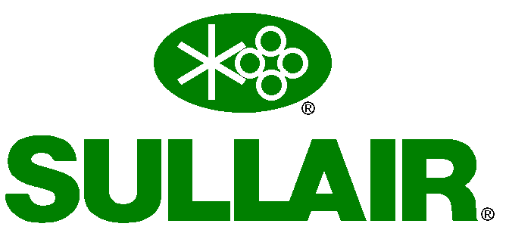
Supplier Deviation Request Form

A | SUPPLIER AND PART INFORMATION
SDR # (Quality to Input)  Date  Originator |  |  |  |  |  |  |  |  | Part Number / Rev Level  Drawing Number
Supplier Name / Vendor# |  |  |  |  |  |  |  |  | Part Description
Supplier Location |  |  |  |  |  |  |  |  | Machine Model / Project
Supplier Contact |  |  |  |  |  |  |  |  | PO Number
Telephone # |  |  |  |  |  |  |  |  | Quantity
Email |  |  |  |  |  |  |  |  | Required Date
B | DEVIATION INFORMATION
Deviation Request is:  (check one) |  |  |  | Product Related |  |  |  |  |  | Process Related
Deviation Request is due to:  (check all that apply) |  |  |  | Dimensional NC  Material Change |  |  |  |  |  | Process Change (new/changed process or location)  Drawing/Spec Change (dimensional/tolerance, paint, mfr. p/n, etc.)
Deviation/change is:  (check one) |  |  |  | Temporary |  |  |  |  |  |  | Permanent (requires ER number below)
IF SDR IS DUE TO A SUPPLIER NON-CONFORMANCE, SUPPLIER MUST PROVIDE CORRECTIVE ACTION NOTED ON THIS SDR FORM TO ENSURE NON-RECURRENCE.
Current Specification or Process |  |  |  |  |  |  |  | Proposed Deviation |  |  |  |  |  | Reason for Deviation  Corrective Action
C | SULLAIR APPROVAL/DISAPPROVAL
 |  | Printed Name & Signature |  |  |  |  | Approve/  Disapprove |  |  |  | Date | Comments
Supply Chain
Engineering
Quality
Manufacturing
Other
D | DISPOSITION
Document Change Required? |  |  |  |  | Yes | No |  |  | If Yes, ER #
Rework Required? | Yes | No | If Yes,
Comments:

NOTE: Please provide a red-line markup of any requested change to a Sullair print.
(Feel free to use page break if more space is needed).

ISO Revision Log

Revision | Date | Revised By | Description
01 | 03/18/09 | Jeff Stewart | Section “D” Disposition Area: PCA # was revised to read ECO #.
02 | 08/07/2012 | K Maple | Add Rework Required in Section “D”
03 | 01/01/2015 | K Maple | Reviewed no changed
04 | 06/07/2018 | Noe Vega | Added requirement for Printed Name
05 | 6/26/2019 | Terry Dotson | Moved Certification note outside of comment section
06 | 9/26/2019 | Brad Nusbaum | added note for to require RCCA for non-conformances
07 | 12/22/2020 | Barb Kopko | Revised to include Part Number / Rev in same box. Added Model / Project  Removed reference to certifications email box. Revised order of approval
08 | 08/31/2022 | Noe Vega | Updated nomenclature references from ECO to ER. Added note requiring evidence/markup for print change requests. Updated corrective action request note.

